Chain-Of-Hope: Blockchain for Ethical Blood and Organ Matching

Lincy Jemina S1, Gautham Sangaraju2 *, Gunji Venkata Krishna Karthik3

Department of CSE, Panimalar Engineering College, Chennai, India

[lincyyabez@gmail.com](mailto:lincyyabez@gmail.com) , [gauthamsangaraju@gmail.com](mailto:gauthamsangaraju@gmail.com) , [g65252713@gmail.com](mailto:g65252713@gmail.com)

*Corresponding Author Email: Gautham Sangaraju

***Abstract****-***By using blockchain technology to fight unethical behavior and illicit trade, the Chain-Of-Hope initiative offers a revolutionary method for blood and organ donation. The project tackles the worldwide organ trafficking issue while advancing health, justice, and institutional transparency in line with the UN’s Sustainable Development Goals (SDGs 3 and 16). Anonymous, moral, and traceable donor-recipient pairings are guaranteed by the system's secure matching protocol, which is driven by smart contracts and decentralized ledgers. To provide a scalable and reliable platform, the design combines Web3 technologies, Ethereum-based smart contracts, and simulation environments such as Ganache. Through gradual adoption, from pilot projects to widespread adoption, Chain-Of-Hope aspires to a time when every donation is protected by honesty, openness, and cutting-edge technology.**

Keywords**:** Blockchain, Ethical Donation, Smart Contracts, Sustainable Development Goals, Transparency.

**I. INTRODUCTION**

The presentation "Chain-Of-Hope: Blockchain for Ethical Blood & Organ Matching," discusses a ground-breaking project that aims to transform the global management of blood and organ donations. The project's primary focus is the urgent and extremely concerning problem of illicit organ and blood trade, a shadow economy that preys on disadvantaged groups and threatens public health systems. The project aims to eliminate the risks of corruption, exploitation, and data manipulation by utilizing blockchain technology to establish a safe, open, and ethical framework for donor-recipient matching.

The United Nations Sustainable Development Goals (SDGs 3 and 16), which promote health, well-being, peace, and robust institutions, are particularly aligned with this approach. Chain-Of-Hope ensures that each donation is traceable, anonymous, and ethically validated using smart contracts and decentralized ledgers. This presentation highlights the platform's ability to rebuild trust in the donation process and establish a new global standard for medical ethics and transparency, while outlining its technical design, implementation timeline and future goals.

**II. LITERATURE REVIEW**

Recent developments in blockchain technology have generated considerable interest in its potential use in the medical field, especially in systems for data sharing and organ donation. According to Ramanathan et al. (2025), a comprehensive analysis of 15 peer-reviewed publications demonstrated a wide variety of approaches, such as decentralized data structures, Ethereum-based smart contracts, and Hyperledger Fabric frameworks. These studies continuously highlight how blockchain can improve operational efficiency, security, and transparency when handling sensitive medical data and donor-recipient matching procedures.

The conclusions derived from these efforts demonstrate how blockchain technology may lower fraud, guarantee ethical adherence, and facilitate traceable transactions across networks of organ donors. However, the literature also points to several drawbacks, including expensive implementation costs, scalability issues, a lack of practical deployment, and unresolved privacy and interoperability issues. Notwithstanding these limitations, the combined results support the potential of blockchain as a game-changing instrument for creating reliable and moral healthcare systems.

**III. EXISTING SYSTEM**

The current blood and organ donation systems rely heavily on centralized databases, leading to several inefficiencies and ethical issues. This paradigm gives central authorities complete control over data exchange and authentication because all donor and receiver information is kept in government- or hospital-controlled systems. In addition to limiting transparency, this centralized method raises the possibility of data breaches and illegal access to data.

To verify identity and donor eligibility, the existing system mostly uses manual or semi-digital verification procedures that rely on paper records or hospital-issued identification cards. This approach takes a long time and is prone to human error. Furthermore, there is a severe lack of real-time traceability; once a donation takes place, it is challenging to follow its path through the healthcare system because blood banks and hospitals share information in separate databases. Because centrally stored sensitive health data are susceptible to identity theft and misuse, trust and security concerns exacerbate the situation. Finally, people do not own their personal information; hospitals and blood banks maintain control, making it impossible for users to monitor or control how their data are utilized.

**DRAWBACKS**

There are several serious issues with the current system for handling donor data and organ or blood donation procedures. Because of the susceptibility of servers to hacking and illegal access, centralized data storage presents serious privacy problems. Coordinated care is hampered by a noteworthy lack of interoperability, which makes it difficult to transfer donor information between institutions or across state lines. Owing to the potential for modified eligibility reports and fake donor IDs, the system is potentially vulnerable to identity fraud. Donors also have no insight or control over the use of their personal health information, which limits their control over it.

The lack of an unchangeable past raises serious concerns because it makes it possible to hide or change usage logs and donation information. Verification and matching procedures are slowed down by paperwork and procedural delays, which further increase administrative inefficiency. Finally, the system lacks a systematic way to identify or compensate consistent, qualified donors, resulting in inadequate incentives. These drawbacks highlight the urgent need for a safe, open, and user-focused substitute, such as blockchain-integrated systems with self-governing identity frameworks.

**IV. PROPOSED SYSTEM**

1. SYSTEM ARCHITECTURE

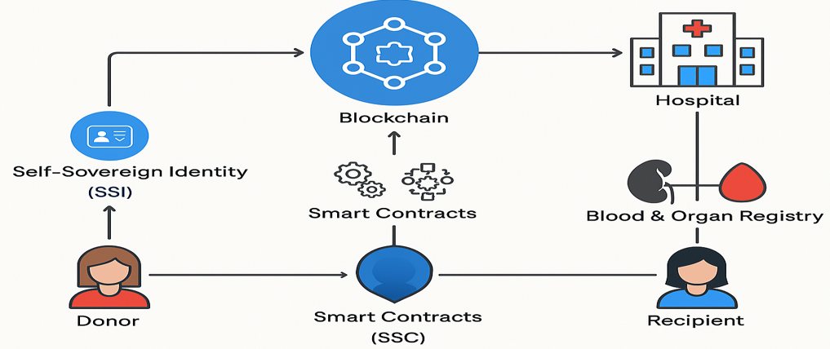

Fig. 1. Chain-Of-Hope: Blockchain for Ethical Blood & Organ Matching

This diagram depicts a blockchain-based system for managing blood and organ donations using smart contracts and self-sovereign identity (SSI). The process begins with the donor, who controls their identity via SSI, ensuring the privacy and ownership of their personal information. Both donors and recipients interact with smart contracts that automate and enforce agreements within the system. These smart contracts are connected to a blockchain, providing a secure and immutable ledger for recording transactions and data. Hospitals access this blockchain to manage blood and organ registries, facilitating the matching and allocation of donations. Ultimately, the recipient benefits from this streamlined, transparent, and secure system that leverages blockchain technology to enhance trust and efficiency in the donation process.

**B. MODULE DESCRIPTION**

The proposed system consists of 7 modules

**1 User Registration and Authentication (with Self-Sovereign Identity)**

**2. Consent and Data Authorization**

**3. Medical Data Collection and Upload**

**4. Blood & Organ Matching Engine**

**5. Blockchain Ledger & Audit Trail**

**6. Notifications and Emergency Alerts**

**7. Admin Dashboard**

**Module 1: User Registration and Authentication (with Self-Sovereign Identity)**

It allows people to use blockchain-based self-sovereign identities to safely register and manage their identities. guarantees personal information management and privacy without depending on a centralized authority.

**Module 2: Consent and Data Authorization**

It allows users to grant or revoke access to their medical data for specific purposes. Maintains transparent consent records on the blockchain to ensure ethical compliance.

**Module 3: Medical Data Collection and Upload**

It makes it easier to submit test results, medical data, and other health information securely. verifies the validity and integrity of the data before placing it on the blockchain.

**Module 4: Blood & Organ Matching Engine**

Donors and recipients are automatically paired according to ethical standards, urgency, and compatibility. maximizes the distribution for equitable and life-saving effectiveness.

**Module 5: Blockchain Ledger & Audit Trail**

It maintains an immutable record of every action and transaction on the blockchain. ensures regulatory compliance, transparency, and confidence by providing a verifiable audit trail.

**Module 6: Notifications and Emergency Alerts**

It sends real-time alerts to donors, recipients, and medical staff regarding matches or emergencies. It ensures timely intervention for critical medical needs.

**Module 7: Admin Dashboard**

It provides a consolidated interface for user management and system activity monitoring. provides supervision, reports, and analytics to ensure operational effectiveness and compliance.

**V. RESULTS AND DISCUSSIONS**

The "Code Of Hope" architecture uses cutting-edge blockchain technology to provide ethical blood and organ matching while prioritizing security, transparency, and scalability. A front-end application for user interaction, Web3 technology integration, and implementation of Solidity-written smart contracts are some of the system's essential elements. Using Ganache for development and testing, it runs on a local blockchain network and maintains an immutable, safe blockchain ledger to document transactions. To guarantee the dependability and seamless operation of the entire process, the design also facilitates transaction simulations.

**SCREENSHOTS**

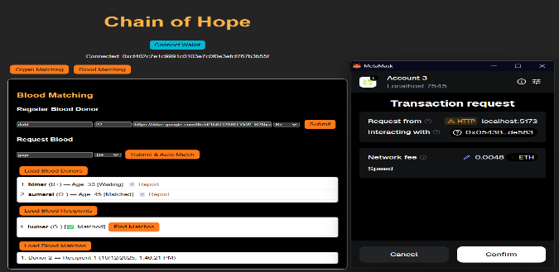

Fig. 2. Screenshot of Blood Matching

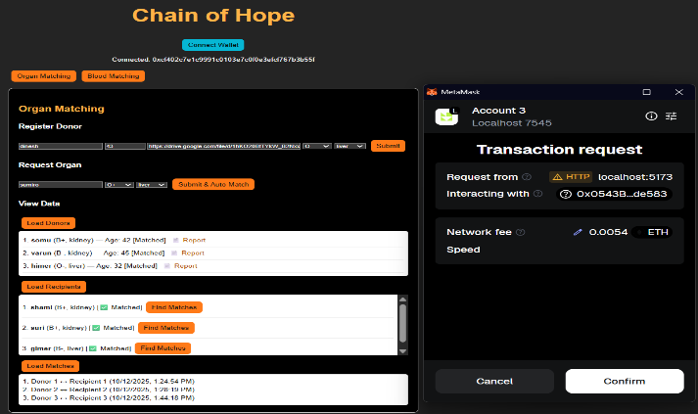

Fig. 3. Screenshot of Organ Matching

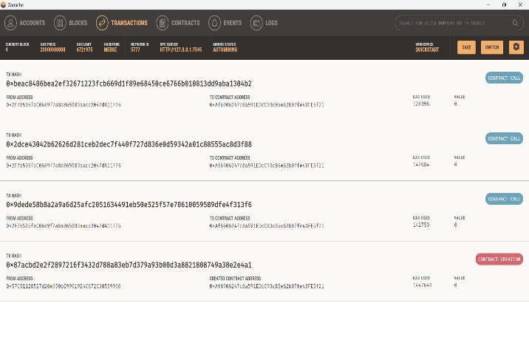 Fig. 4. Screenshot of Ganache Transactions

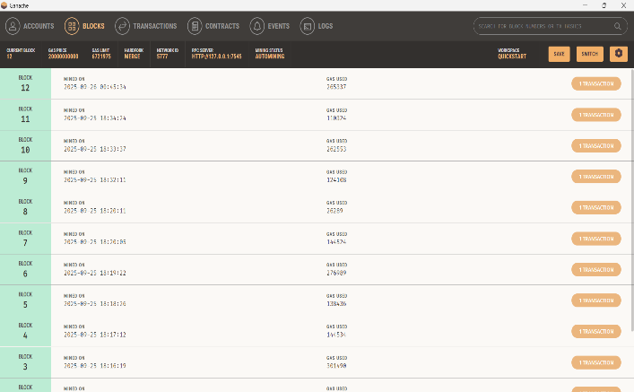

Fig. 5. Screenshot of Ganache Blocks

**VI. CONCLUSION**

The Chain-Of-Hope concept shows how blockchain technology can transform the healthcare industry by guaranteeing security, trust, and transparency in the vital procedures of organ and blood donation. This technology ensures that donations are matched in an ethical and effective manner while reducing the dangers of fraud, illicit trade, and data manipulation by using decentralized ledgers and smart contracts. Additionally, the immutability and traceability of blockchain records boost trust between donors and recipients, encouraging increased involvement and equity. In the end, Chain-Of-Hope not only tackles the technological difficulties of safe data storage but also fortifies the moral underpinnings of life-saving medical procedures, opening the door to a more just and reliable healthcare system that protects patient privacy.

**REFERENCES**

[1] B. V. Santhosh Krishna, B. Rajalakshmi, K. Ashok, I. H. Gundoo and I. Aryan, "Self Sovereign Identity - Blockchain based Blood Donation Management Method," *2023 International Conference on Sustainable Computing and Smart Systems (ICSCSS)*, Coimbatore, India, 2023, pp. 1512-1520, doi: 10.1109/ICSCSS57650.2023.10169274.

[2] L. Goudjil, S. Cherbal, N. E. Otmani, A. E. Khamedj, A. S. Mashaleh and A. Gawanmeh, "Leveraging Blockchain and IoMT for a Smart Blood Donation System," *2025 1st International Conference on Computational Intelligence Approaches and Applications (ICCIAA)*, Amman, Jordan, 2025, pp. 01-06, doi: 10.1109/ICCIAA65327.2025.11013492.

[3] C. Niyigena, S. Seol and A. Lenskiy, "Survey on Organ Allocation Algorithms and Blockchain-based Systems for Organ Donation and Transplantation," *2020 International Conference on Information and Communication Technology Convergence (ICTC)*, Jeju, Korea (South), 2020, pp. 173-178, doi: 10.1109/ICTC49870.2020.9289421.

[4] S. Preethi and C. Priyadharsini, "A Literature Review on Secured Data Management using Block Chain Technology in Healthcare Sector," *2021 International Conference on Smart Generation Computing, Communication and Networking (SMART GENCON)*, Pune, India, 2021, pp. 1-5, doi: 10.1109/SMARTGENCON51891.2021.9645826.

[5] E. S. Priya and R. Priya, "Data Encryption of Blood-chain data in Blockchain Network," *2023 International Conference on Networking and Communications (ICNWC)*, Chennai, India, 2023, pp. 1-9, doi: 10.1109/ICNWC57852.2023.10127347.

[6] K. P and J. N, "Synergistic Revolution with AI-Enabled Organ Matching and Blockchain Security in Transplantation Management," *2024 Second International Conference on Advances in Information Technology (ICAIT)*, Chikkamagaluru, Karnataka, India, 2024, pp. 1-6, doi: 10.1109/ICAIT61638.2024.10690290.

[7] W. Zi-chen, W. Xiao-yu, Y. Wan-jun, L. Jia-lan, Z. Huai-lin and C. Nai-meng, "Medical Information Storage Model Based on Block Chain," *2019 International Conference on Intelligent Informatics and Biomedical Sciences (ICIIBMS)*, Shanghai, China, 2019, pp. 39-44, doi: 10.1109/ICIIBMS46890.2019.8991479.

[8] R. Roy and S. Pillai, "Intelligent Decision Making with Block chain in healthcare industry," *2022 International Interdisciplinary Humanitarian Conference for Sustainability (IIHC)*, Bengaluru, India, 2022, pp. 131-135, doi: 10.1109/IIHC55949.2022.10059753.

[9] J. N. P. Markavathi, R. Pandiarajan, S. Gurumoorthy, M. Madhankumar, V. Sharmi and J. Priyadharshika, "Blood Bank Management System: Enhancing Security and Transparency in Blood Donation," *2024 International Conference on IT Innovation and Knowledge Discovery (ITIKD)*, Manama, Bahrain, 2025, pp. 1-6, doi: 10.1109/ITIKD63574.2025.11005103.

[10] S. Sadri, A. Shahzad and K. Zhang, "Blockchain Traceability in Healthcare: Blood Donation Supply Chain," *2022 24th International Conference on Advanced Communication Technology (ICACT)*, PyeongChang Kwangwoon_Do, Korea, Republic of, 2022, pp. 1-8, doi: 10.23919/ICACT53585.2022.9728950.

[11] L. A. Dajim, S. A. Al-Farras, B. S. Al-Shahrani, A. A. Al-Zuraib and R. Merlin Mathew, "Organ Donation Decentralized Application Using Blockchain Technology," *2019 2nd International Conference on Computer Applications & Information Security (ICCAIS)*, Riyadh, Saudi Arabia, 2019, pp. 1-4, doi: 10.1109/CAIS.2019.8769459.

[12] D. Hawashin, R. Jayaraman, K. Salah, I. Yaqoob, M. C. E. Simsekler and S. Ellahham, "Blockchain-Based Management for Organ Donation and Transplantation," in *IEEE Access*, vol. 10, pp. 59013-59025, 2022, doi: 10.1109/ACCESS.2022.3180008.

[13] H. D. Das, R. Ahmed, N. Smrity and L. Islam, "BDonor: A Geo-localised Blood Donor Management System Using Mobile Crowdsourcing," *2020 IEEE 9th International Conference on Communication Systems and Network Technologies (CSNT)*, Gwalior, India, 2020, pp. 313-317, doi: 10.1109/CSNT48778.2020.9115776.

[14] D. D. Priya, M. Naga Sreeya, A. Sanjana, P. Sarayu and M. K. Swamy, "Enhancing Organ Donor Matching and Transparency with Blockchain Technology," *2024 International BIT Conference (BITCON)*, Dhanbad, India, 2024, pp. 1-5, doi: 10.1109/BITCON63716.2024.1098570.

[15] N. R. Kypu, B. K, D. V. Korla, V. Dwarakacharla and S. V. K, "BlockchainBased Organ Donation System: A Decentralized Solution for Transparent and Secure Transplant Matching," 2024 International Conference on Sustainable Communication Networks and Application (ICSCNA), Theni, India, 2024, pp. 439-443, doi:10.1109/ICSCNA63714.2024.10864115.